**IDEATION PHASE**

**DEFINE THE PROBLEM STATEMENTS**

|  |  |
| --- | --- |
| **Date** | **04 May 2023** |
| **Team ID** | **NM2023TMID04681** |
| **Project name** | **BUILD AN EVENT MANAGEMENT SYSTEM** |
| **Maximum marks** | **2 marks** |

**BUILD AN EVENT MANAGEMENT SYSTEM USING SALESFORCE**

|  |  |  |  |  |  |
| --- | --- | --- | --- | --- | --- |
| **Problem statements**  **(ps)** | **I am** | **I'm trying to** | **But** | **Because** | **Which makes me feel** |
| **Ps-1** | CUSTOMER 1 | I am trying to streamline and simplify the process of submitting, tracking | But the current process is manual, time consuming, | Because this inefficiency in the event approval process creates frustration, adds unnecessary administrative work | Which makes me feel frustrated, anxious about tra plans, and often uncertain about the status of my request |
| **Ps-2** | CUSTOMER 2 | Approving event requests to ensure a smoother event experience | Lacks transparency, resulting in delays and confusion. | It can lead to financial discrepancies | Ultimately affecting my overall job satisfaction and productivity |

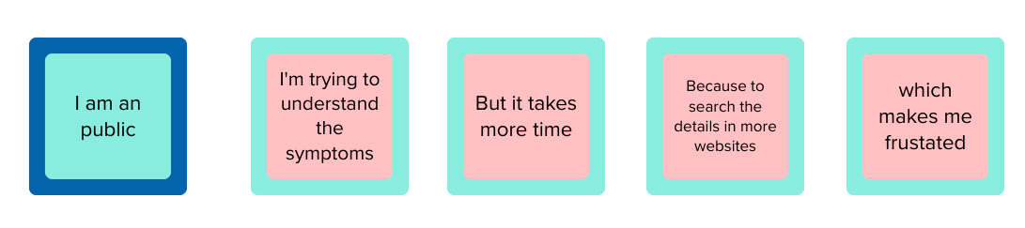

CUSTOMER

I am trying to streamline and simplify the process of submitting, tracking

But the current process is manual, time consuming

Which makes me feel frustrated, anxious about tra plans, and often uncertain about the status of request

Because this inefficiency in the event approval process creates frustration, adds unnecessary administrative work